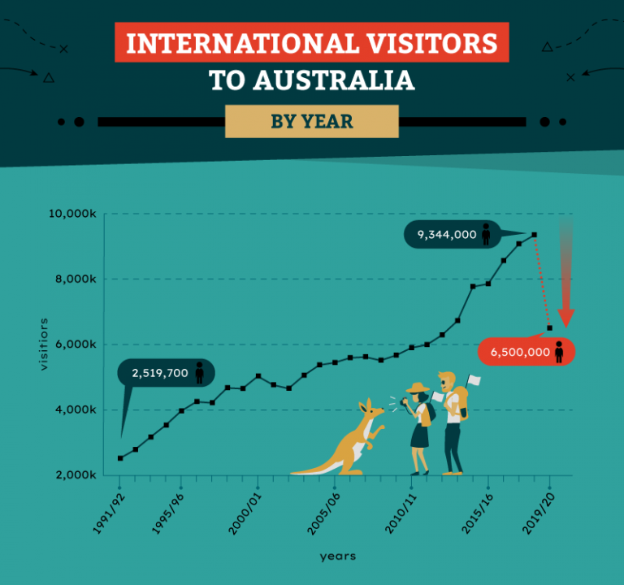
Source 1: International Visitors to Australia: By Year. Source ABS Statistics.

